Mountains of Ararat
Genesis 8:4
And the ark rested in the seventh month, on the seventeenth day of the month, upon the mountains of Ararat[H780].
2 Kings 19:37 (after Sennacherib king of Assyria returned to Nineveh during the reign of king Hezekiah)
And it came to pass, as he was worshipping in the house of Nisroch his god, that Adrammelech and Sharezer his sons smote him with the sword: and they escaped into the land of Armenia[H780]. And Esarhaddon his son reigned in his stead.
Isaiah 37:38 (after Sennacherib king of Assyria returned to Nineveh during the reign of king Hezekiah)
And it came to pass, as he was worshipping in the house of Nisroch his god, that Adrammelech and Sharezer his sons smote him with the sword; and they escaped into the land of Armenia[H780]: and Esar-haddon his son reigned in his stead.
Jeremiah 51:27 (prophecy against Babylon)
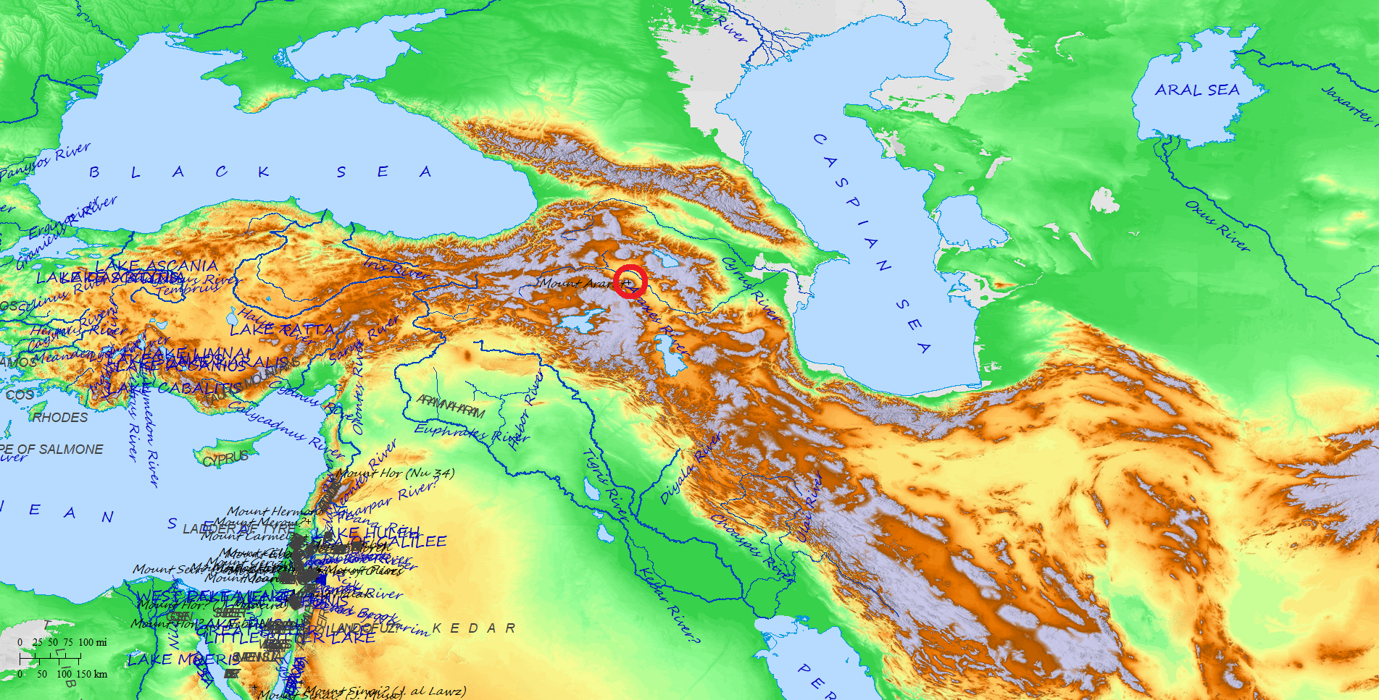
Set ye up a standard in the land, blow the trumpet among the nations, prepare the nations against her, call together against her the kingdoms of Ararat[H780], Minni, and Ashchenaz; appoint a captain against her; cause the horses to come up as the rough caterpillers.
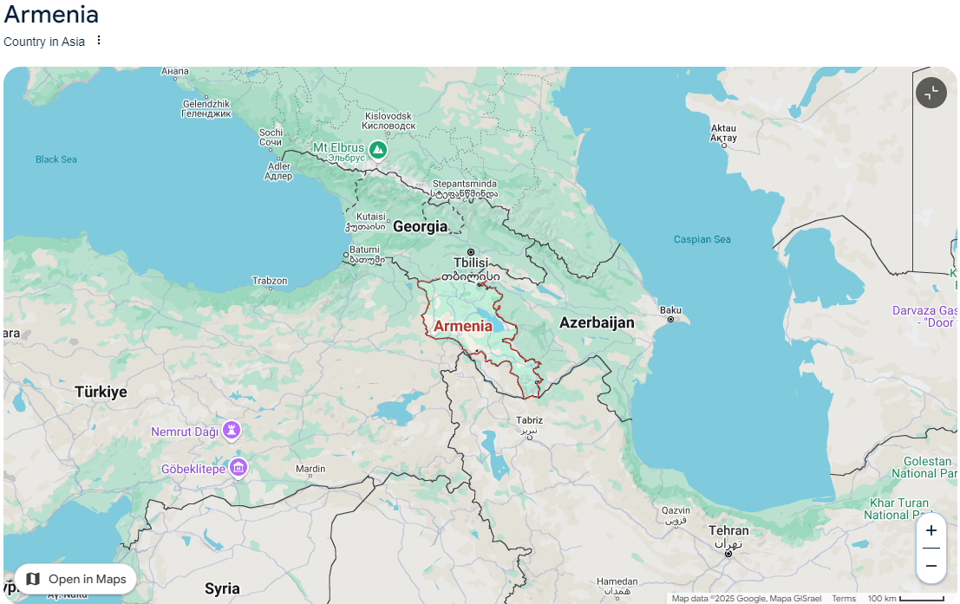

Software used to create maps:
Biblemapper 3.0
NOTE: the map colors are based on topography

